Project Design Phase-II
Technology Stack (Architecture & Stack)

Date | 28 June 2026
Team ID
Project Name | SB Stocks – Paper Trading Platform
Maximum Marks | 4 Marks

Technical Architecture Diagram
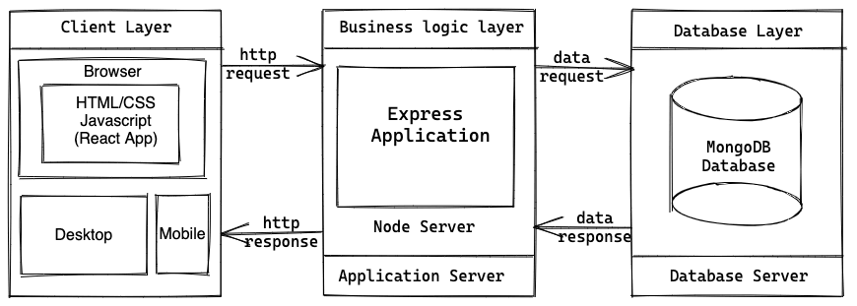

Table-1 : Components & Technologies
S.No | Component | Description | Technology
1 | User Interface | User interacts with the application through a responsive web interface | React.js, Bootstrap, HTML5, CSS3, JavaScript
2 | Application Logic-1 | User Registration and Login | Node.js, Express.js
3 | Application Logic-2 | Portfolio Management (Buy/Sell Stocks) | Express.js REST APIs
4 | Application Logic-3 | Dashboard & Transaction Processing | Node.js, Express.js
5 | Database | Stores users, stocks, portfolio, and transactions | MongoDB Atlas (NoSQL)
6 | Cloud Database | Cloud-hosted database | MongoDB Atlas
7 | File Storage | Static assets and project files | Local File System
8 | External API-1 | REST API communication between frontend and backend | Axios
9 | External API-2 | Authentication API | JWT (JSON Web Token)
10 | Machine Learning Model | Not Applicable in current project | N/A
11 | Infrastructure (Server / Cloud) | Frontend hosted on Vercel and Backend hosted on Render | Vercel, Render

Table-2 : Application Characteristics
S.No | Characteristics | Description | Technology
1 | Open-Source Frameworks | Frontend and backend developed using open-source frameworks | React.js, Node.js, Express.js, Bootstrap
2 | Security Implementations | User authentication using JWT, password protection, protected API routes | JWT Authentication, Express Middleware
3 | Scalable Architecture | Three-tier architecture separating presentation, business logic, and database | React.js + Express.js + MongoDB
4 | Availability | Cloud deployment enables users to access the application from anywhere with internet connectivity | Vercel, Render, MongoDB Atlas
5 | Performance | Lightweight REST APIs, asynchronous requests, and optimized frontend rendering | Axios, React Hooks, Express.js
6 | Maintainability | Modular folder structure for easy development and maintenance | React Components, Express Routes
7 | Responsiveness | Responsive user interface compatible with desktop, tablet, and mobile devices | Bootstrap 5
8 | Data Management | Efficient storage and retrieval of user, stock, portfolio, and transaction data | MongoDB Atlas
9 | API Communication | Secure communication between frontend and backend | REST API, Axios
10 | Deployment | Cloud-based deployment for frontend and backend services | Vercel, Render

References
- https://c4model.com/
- https://developer.ibm.com/patterns/
- https://www.ibm.com/cloud/architecture
- https://aws.amazon.com/architecture
- https://react.dev/
- https://expressjs.com/
- https://www.mongodb.com/
- https://nodejs.org/
- https://vercel.com/
- https://render.com/

